
EXPENSE TRACKER SYSTEM
Course Code: CSEG1032
Course Title: Programming in C Project
Student Names: Vibha Dubey
SAP ID: 590026089
ABSTRACT
The Expense Tracker System is a lightweight yet efficient software application developed to help users systematically record, manage, and analyze their daily expenses. The primary objective of this project is to assist individuals in maintaining a digital log of their expenditure patterns, thereby promoting better financial awareness and budgeting.
The system provides essential features such as adding new expenses, viewing previously recorded entries, editing or updating existing records, deleting unwanted data, and filtering expenses based on specific categories or dates. These functionalities make the application both practical and user-friendly.
This project has been developed using the C programming language, utilizing file handling techniques to ensure persistent storage of user data. The report provides a detailed explanation of the system design, flowcharts, algorithms, implementation details, and results obtained during testing.

Problem Definition

Introduction

In today’s fast-paced life, people often struggle to keep track of their daily spending. The Expense Tracker project addresses this issue by offering a digital tool to record and monitor expenses. It highlights how C programming can be applied to solve real-life problems efficiently.

What It Is

The Expense Tracker is a menu-driven program developed in C. It allows users to:

Add new expense entries (date, category, amount, description)

View all recorded expenses

Search/filter expenses by category or date

Calculate total expenditure

Store data permanently using file handling

Why We Need This

To encourage financial discipline and awareness

To replace manual expense tracking with a digital solution

To apply theoretical C programming concepts in practice

To learn file handling, data management, and debugging

To build a foundation for advanced financial applications

SYSTEM DESIGN

The Expense Tracker System is built with a modular, file-based architecture that ensures simplicity, accuracy, and smooth data handling.
Its design focuses on five core operations—Add, View, Edit, Delete, and Filter—each working together to create a seamless expense-management .
Algorithm overview:
Step 1: Start
Step 2: Display menu options to the user
Step 3: Accept user choice
Step 4: Perform corresponding function using switch-case
Case 1: Add Expense
- Accept input and save to file
Case 2: View Expense
- Read and display all records
Case 3: Edit Expense
- Search and update record
Case 4: Delete Expense
- Remove record by date
Case 5: Filter Expense
- Show records by category
Case 6: Summary
- Calculate and display total
Case 7: Exit
Step 5: Repeat until Exit
Step 6: End

Flowchart overview:
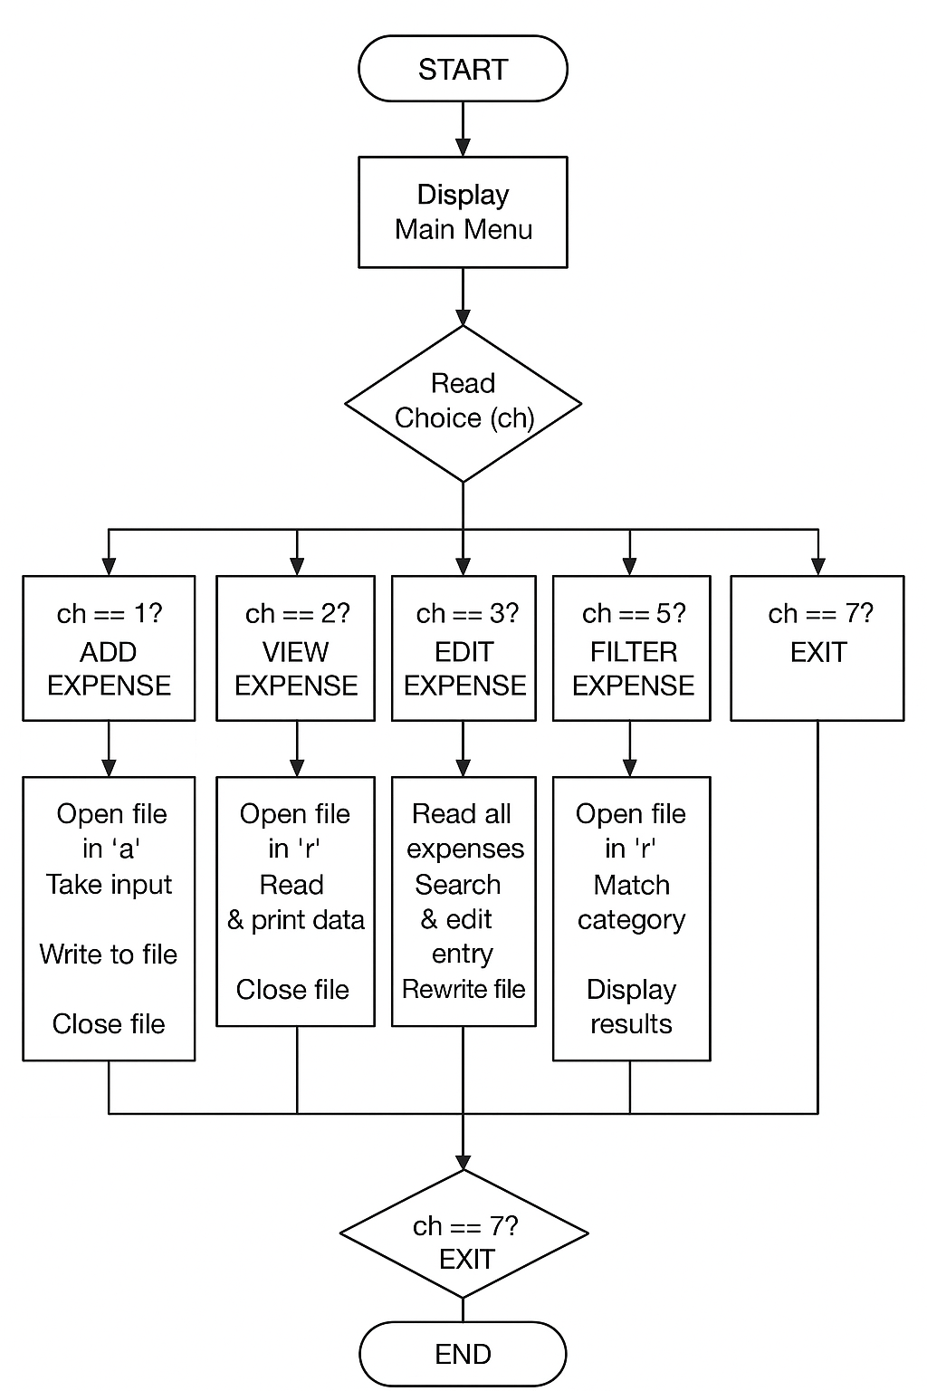

Implementation Details

i)-Structure Used
struct expenses
{
char date[20], group[100], description[200];
int price;
};

ii)-Adding Expense
void addexpense() {
FILE *fp = fopen("expense.txt", "a");
if (!fp) {
printf("Error opening file!\n");
return;
}

printf("Enter date: ");
scanf("%s", ex.date);
printf("Enter group: ");
scanf("%s", ex.group);
printf("Enter description: ");
scanf("%s", ex.description);
printf("Enter price: ");
scanf("%d", &ex.price);
fprintf(fp, "%s %s %d %s\n", ex.date, ex.group, ex.price, ex.description);
fclose(fp);
printf("Expense added successfully!\n");
}
iii)- Viewing Expenses
void viewexpense() {
FILE *fp = fopen("expense.txt", "r");
if (!fp) {
printf("No data found!\n");
return;
}
while (fscanf(fp,"%s %s %d %s", ex.date, ex.group, &ex.price, ex.description) != EOF) {
printf("%s %s %d %s\n", ex.date, ex.group, ex.price, ex.description);
}
fclose(fp);
}
iv)- Editing, Deleting, Filtering
- The chosen record is skipped while rewriting the file.
- All other entries are saved again.
- Efficiently removes unwanted records.

• Filter Expense
- Allows filtering based on:
  - Category
  - Date
- Displays only selected results.
- Helps in focused expense analysis.

Testing & Results

Testing each feature to ensure accuracy, correctness, and smooth performance. Debugging errors to improve reliability.
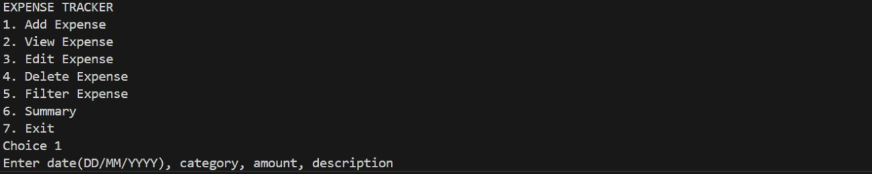
Choice 1.
Choice 2.
Choice 3.
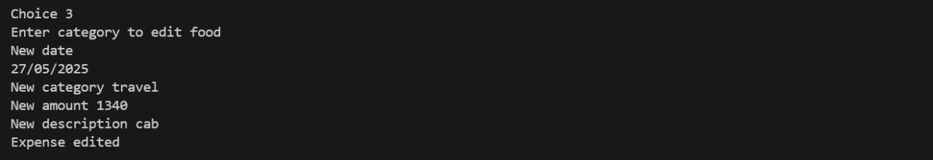
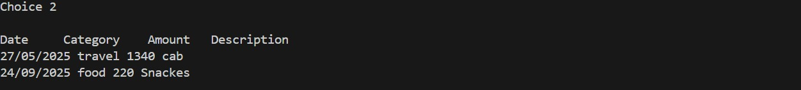
Choice 4.
Choice 5.
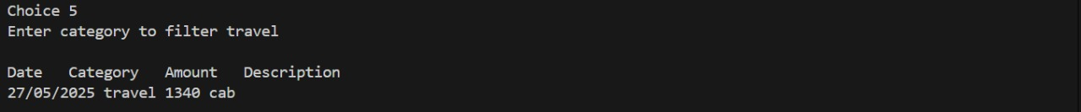
Choice 6.
Choice 7.

Conclusion & Future

Conclusion

The Expense Tracker system successfully provides a basic platform for maintaining and monitoring daily expenditures. Using C language and file handling, the project ensures persistent data storage and easy retrieval. It is simple, lightweight, and effective for students or individuals.

Future Work
- Add password protection for security Use CSV format for better data handling
- Add graphical interface using C++ or Python
- Include charts for expense analysis
- Export reports to PDF or Excel
Applications
1. Personal Budgeting:
Helps individuals track daily, weekly, or monthly expenses
2. Student Finance Management:
Useful for students managing limited budgets
3. Small Business Expense Logging:
Records operational costs for small businesses
4. Household Expense Monitoring:
Tracks groceries, bills, and other household expenditures
5. Travel Expense Recording:
Logs travel-related costs for trips and vacations
6. Financial Analysis Practice:
Teaches basic data analysis and reporting using programming

References
~Let Us C – Yashwant Kanetkar
~Class Notes

Appendix (Optional)
Link of code for project:
https://github.com/vibhadubey210-ctrl/Vibha26089-C-Major-Project

